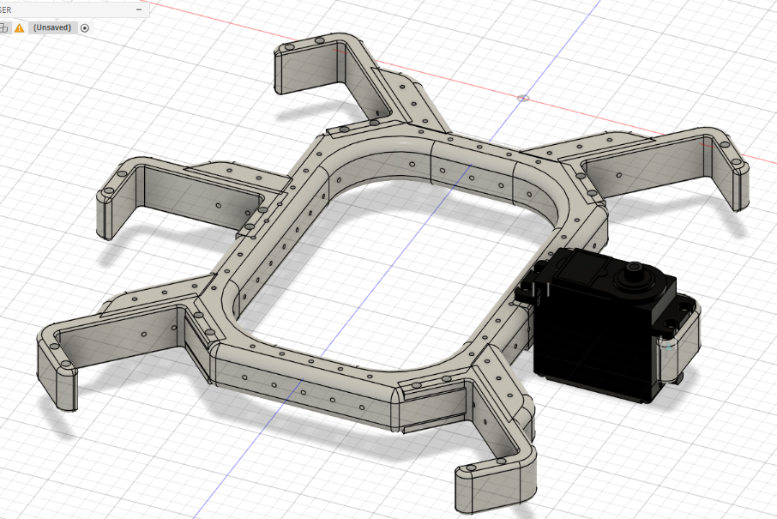Hexapod Mechanical Assembly Guide

|  |
| --- |
| Let’s begin with the assembly. Take all 3D-printed components,  remove any support material, and smooth or polish the edges wherever necessary. |
| 1. **Align the MG995 servo motors with the frame holes.** |
|  |

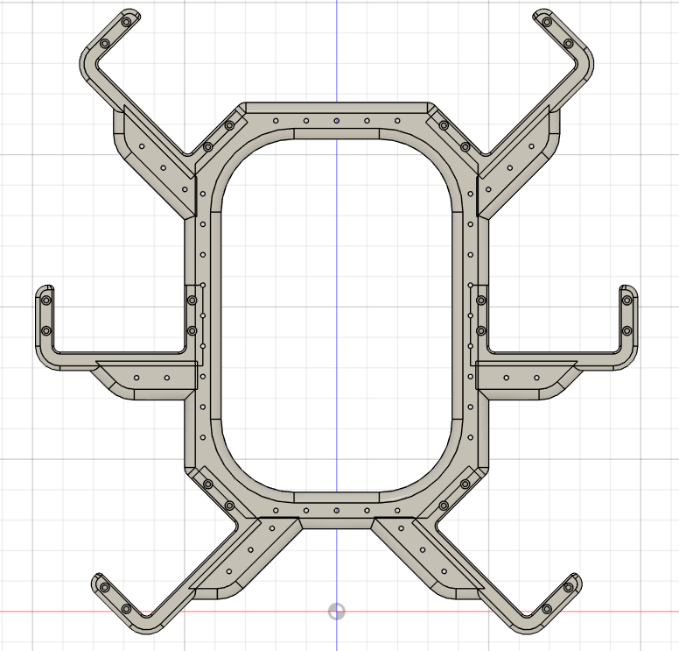



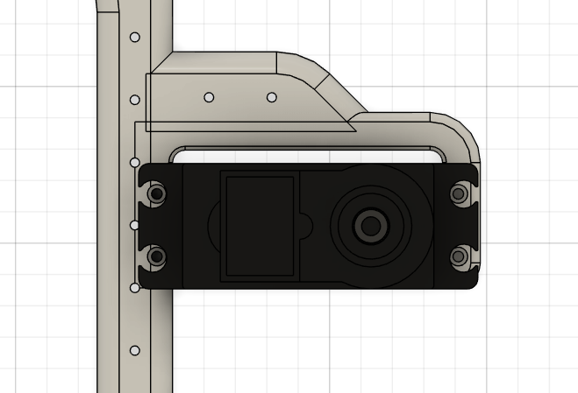

Fix two diagonal screws first; this will be enough to hold it securely. If you feel it is still loose, then install all four screws. Starting with two diagonal screws is recommended.

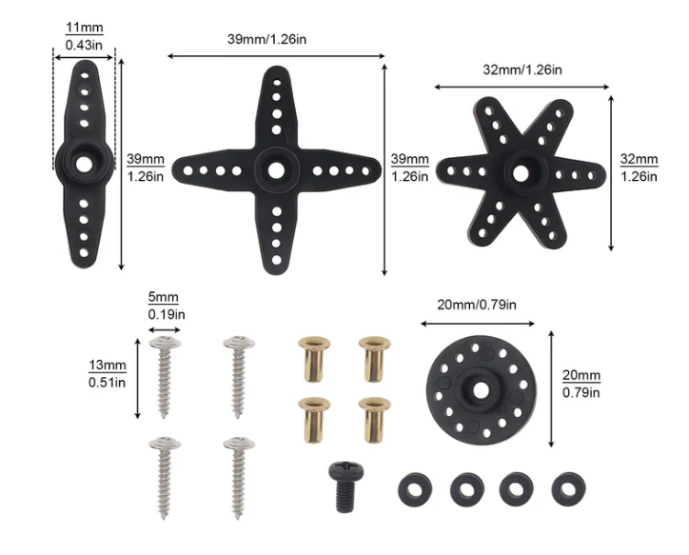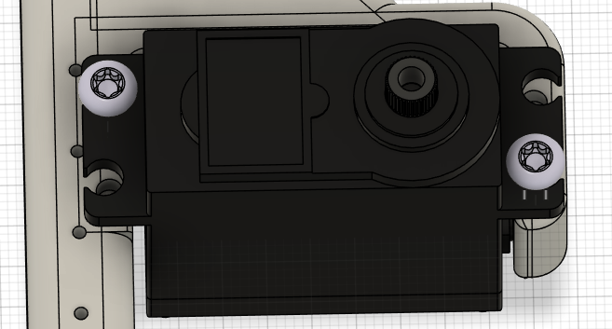(ST2.2x10mm - Use the provided servo mounting screws to securely fix the servo to the frame.)

1. **Control Servo Motors with evive**

<https://ai.thestempedia.com/docs/evive/evive-technical-specifications/plug-play-hardware-interface/servo-motor/>

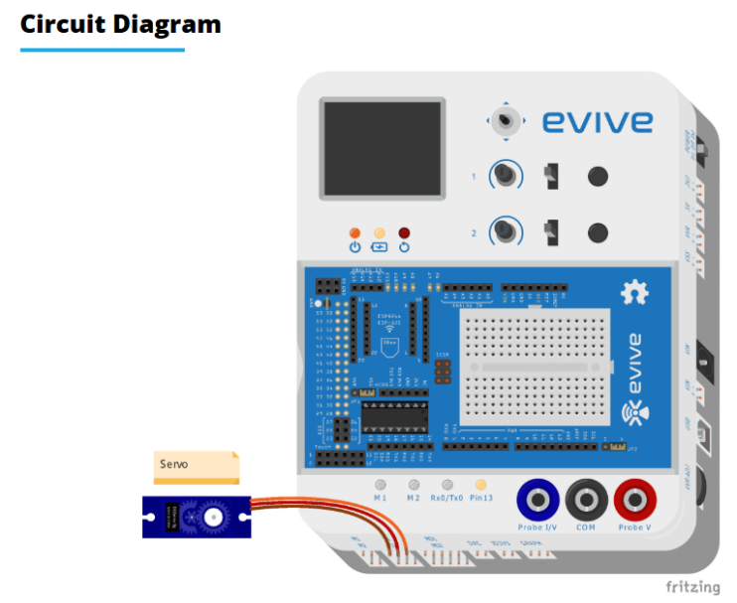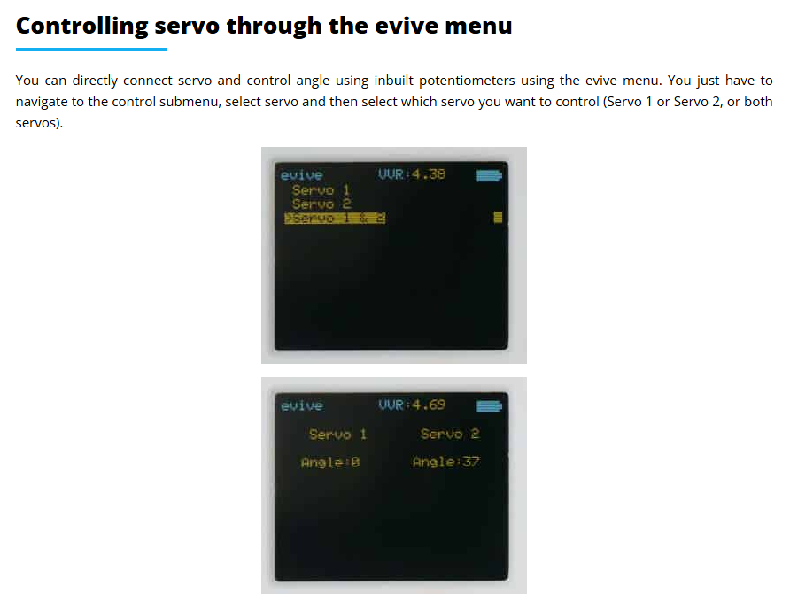

Refer to above link to set the precise servo angle, and ensure the servo is positioned at 90 degrees before proceeding.



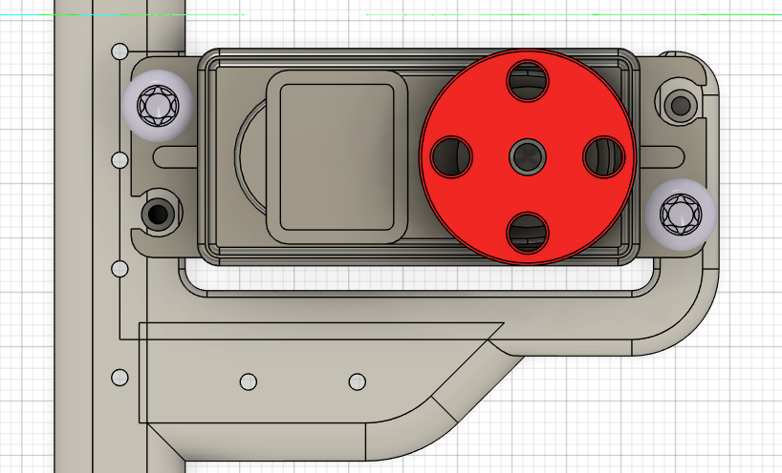

When the servo is set to 90°, ensure the servo horn holes are straight and properly aligned so the Coxa part can be attached correctly. Align the servo horn carefully before fixing the next component.

1. **Proceed to attach the Coxa part.**

Attach the 3D-printed holder to the back of the servo, as shown in the image.

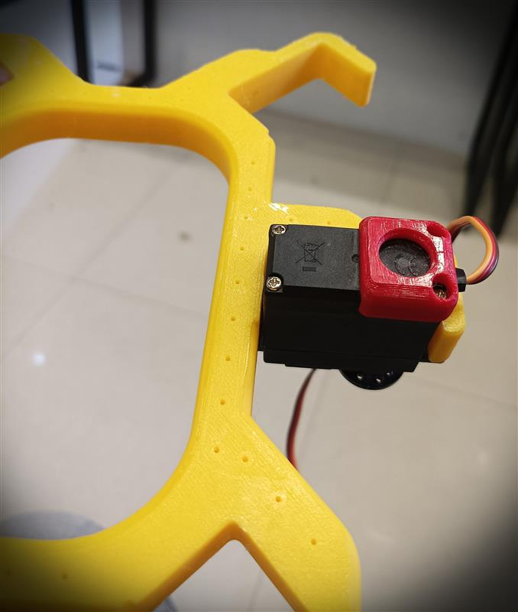

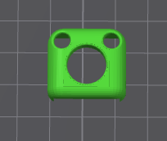

Attach the Coxa mount to the servo horn, carefully align the screw hole, and secure it properly.

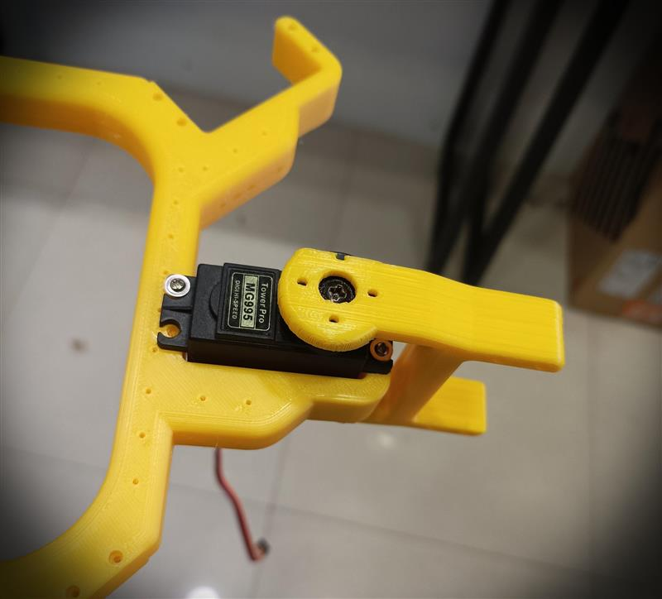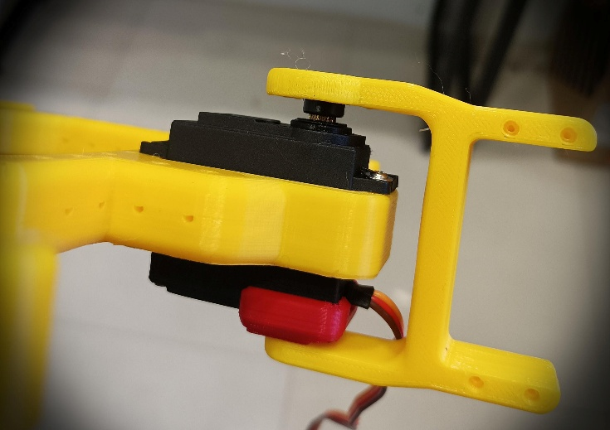

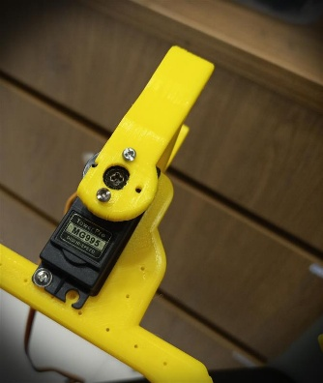Use the center servo horn retaining screw and the ST2.2×5 mm screws around the mount to securely fix it onto the servo shaft.

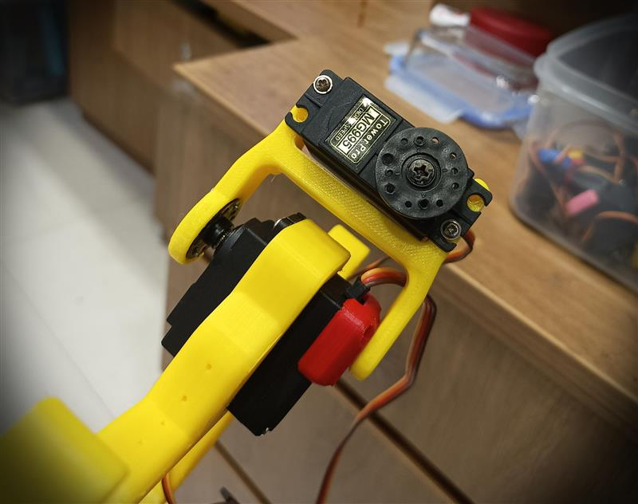Repeat the process: align the servo as shown in the image and secure it properly using the screws.

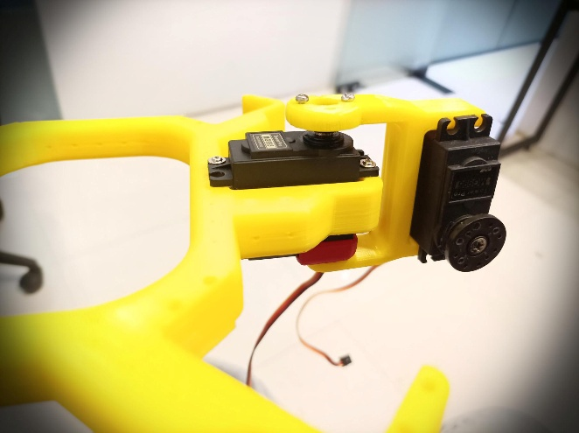

1. **Set the servo to 90°, then attach the Femur to the Coxa.**

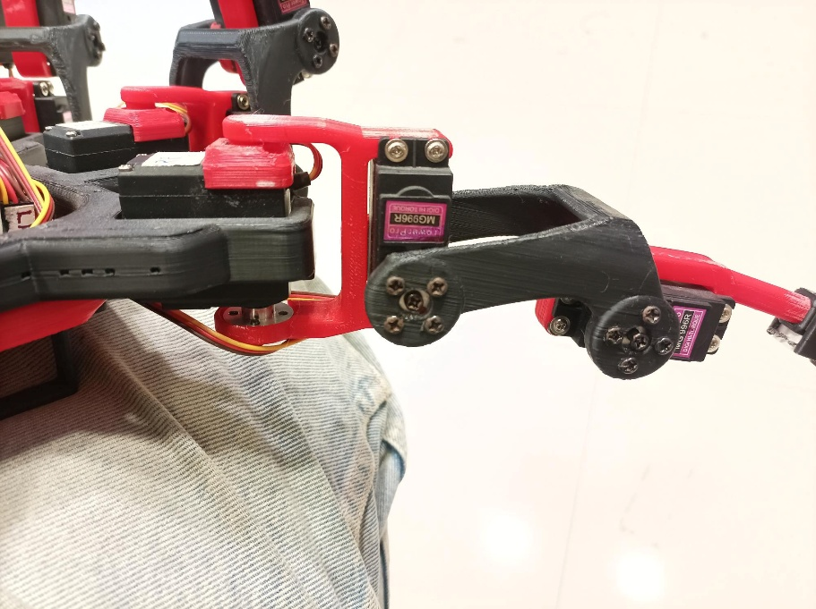

The Femur should be straight and aligned at a 90° angle relative to the Coxa.

1. **First, attach the Tibia to the MG servo.**

Then, in the next step, connect it to the Femur.

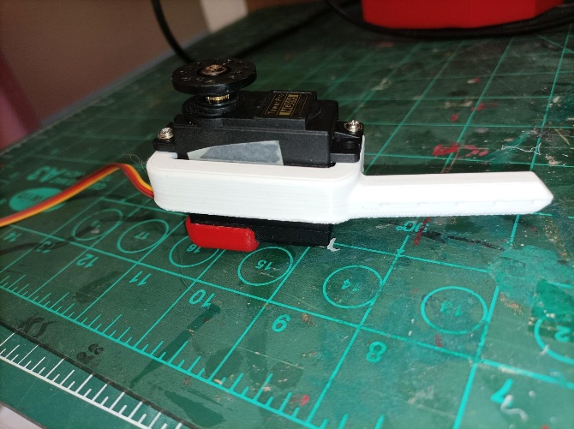

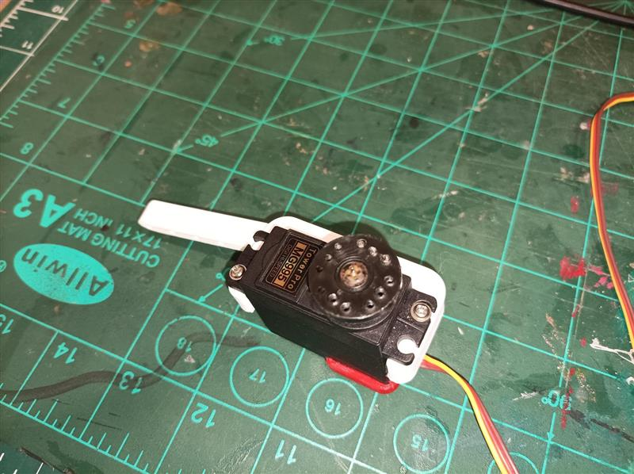

1. **Now attach the Femur and Tibia together, as shown in the image.**

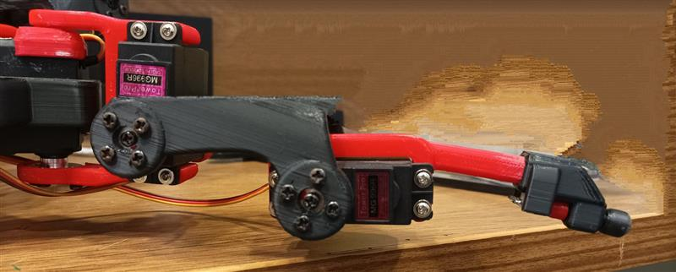

**Congratulations! This completes the assembly of one leg.**

**Note:**

1. Make sure each servo is set to 90° before attaching any part, and tighten min 2 screws enough to securely hold the servos and components together. If requires then fit all 4 screws for more stability.
2. For the opposite side, use the inverted versions of the parts. Remember that three Coxa, Femur, and Tibia components are mirrored (inverted) for the other side.

